Manan Shah – GitHub Repo: https://github.com/manan04shah/bcse203e-web-programming

bcse203e  21/02/2024

Assessment 2

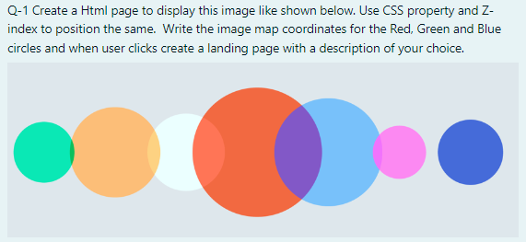

Code:

<!DOCTYPE html>

<html lang="en">

<head>

    <meta charset="UTF-8">

    <meta name="viewport" content="width=device-width, initial-scale=1.0">

    <title>Circles</title>

    <link rel="stylesheet" href="./q1.css">

    <script src="./q1.js"></script>

</head>

<body>

    <map name="circleMap">

        <div class="container">

            <area shape="circle" coords="155, 155, 100" href="q1_landing.html" alt="Green Circle">

            <div class="circle" id="c1" onclick="redirectLanding()">155, 155</div>

            <area shape="circle" coords="255, 155, 125" href="" alt="Orange Circle">

            <div class="circle" id="c2"></div>

            <area shape="circle" coords="355, 155, 118" href="" alt="White Circle">

            <div class="circle" id="c3"></div>

            <area shape="circle" coords="455, 155, 150" href="q1_landing.html" alt="Red Circle">

            <div class="circle" id="c4" onclick="redirectLanding()">455, 155</div>

            <area shape="circle" coords="555, 155, 137" href="q1_landing.html" alt="Light Blue Circle">

            <div class="circle" id="c5" onclick="redirectLanding()">555, 155</div>

            <area shape="circle" coords="655, 155, 75" href="" alt="Pink Circle">

            <div class="circle" id="c6"></div>

            <area shape="circle" coords="755, 155, 113" href="q1_landing.html" alt="Blue Circle">

            <div class="circle" id="c7" onclick="redirectLanding()">755, 155</div>

        </div>

    </map>

</body>

</html>

* {

    margin: 0;

    padding: 0;

}

body {

    background-color: lightgrey;

}

.container {

    position: relative;

    width: 100%;

    height: 100vh;

    display: flex;

    justify-content: center;

    align-items: center;

}

.circle {

    border-radius: 50%;

    position: absolute;

    opacity: 70%;

    display: flex;

    justify-content: center;

    align-items: center;

}

#c1 {

    background-color: green;

    width: 19.5vh;

    height: 19.5vh;

    transform: translateX(-30.5vw);

    z-index: 3;

}

#c2 {

    background-color: orange;

    width: 25vh;

    height: 25vh;

    transform: translateX(-20vw);

    z-index: 1;

}

#c3 {

    background-color:azure;

    width: 23.5vh;

    height: 23.5vh;

    transform: translateX(-10vw);

    z-index: 2;

}

#c4 {

    background-color: red;

    width: 30vh;

    height: 30vh;

    z-index: 0;

}

#c5 {

    background-color: #00b7ff;

    width: 27.5vh;

    height: 27.5vh;

    transform: translateX(9vw);

    z-index: 1;

}

#c6 {

    background-color: palevioletred;

    width: 15vh;

    height: 15vh;

    transform: translateX(18vw);

    z-index: 2;

}

#c7 {

    background-color: blue;

    width: 22.5vh;

    height: 22.5vh;

    transform: translateX(30vw);

}

OUTPUT:

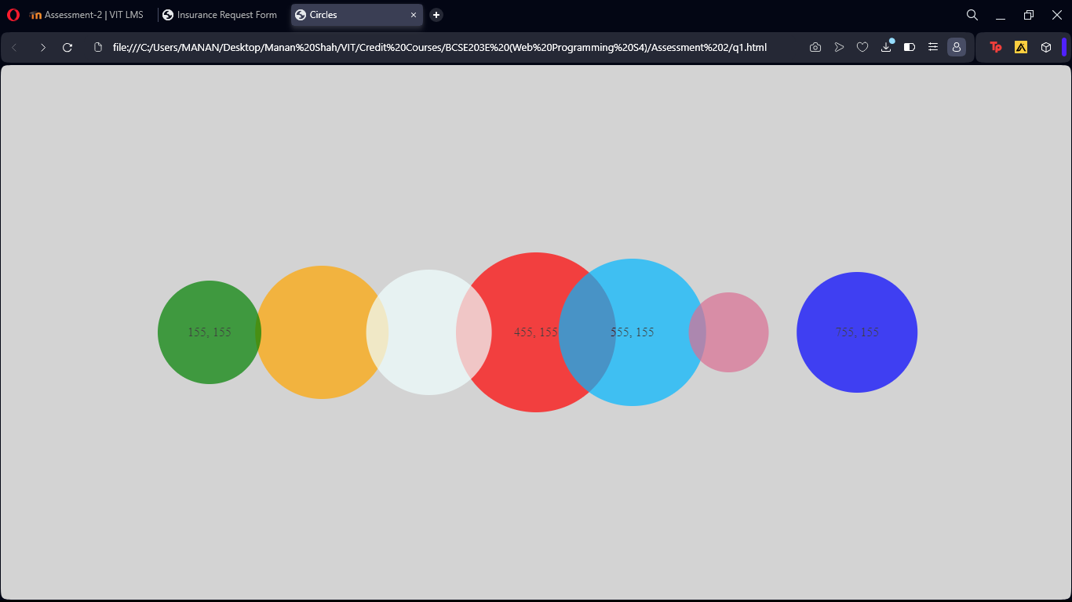

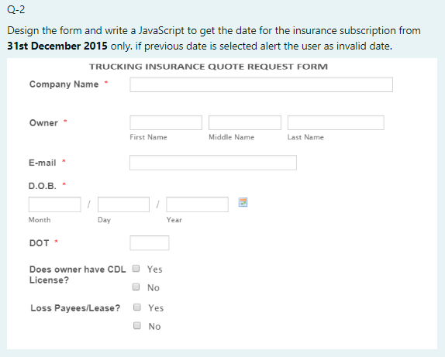

Code:

<!DOCTYPE html>

<html lang="en">

<head>

    <meta charset="UTF-8">

    <meta name="viewport" content="width=device-width, initial-scale=1.0">

    <title>Insurance Request Form</title>

    <link rel="stylesheet" href="./q2.css">

    <script src="./q2.js"></script>

</head>

<body>

    <div class="container">

        <form action="" method="post">

            <div class="formTitle">

                <h1>TRUCKING INSURANCE QUOTE REQUEST FORM</h1>

            </div>

            <div class="formContent">

                <div class="companyName">

                    <label for="companyName">Company Name <span style="color: red;">*</span></label>

                    <input type="text" id="companyName" name="companyName" required>

                </div>

                <div class="owner">

                    <label for="owner">Owner <span style="color: red;">*</span></label>

                    <input type="text" id="owner" name="ownerFirstName" placeholder="First Name" required>

                    <input type="text" name="ownerMiddleName" id="owner" placeholder="Middle Name" required>

                    <input type="text" name="ownerLastName" id="owner" placeholder="Last Name" required>

                </div>

                <div class="email">

                    <label for="email">E-mail <span style="color: red;">*</span></label>

                    <input type="email" id="email" name="email" required>

                </div>

                <div class="dob">

                    <label for="dob">D.O.B. <span style="color: red;">*</span></label>

                    <input type="date" id="dob" name="dob" required>

                </div>

                <div class="dot">

                    <label for="dot">DOT <span style="color: red;">*</span></label>

                    <input type="text" id="dot" name="dot" required>

                </div>

                <br>

                <div class="licenseBoolean" style="display: flex;">

                    <label for="licenseBoolean">Does owner have CDL License?</label>

                    <div class="radioDiv">

                        <span><input type="radio" id="licenseBoolean" name="licenseBoolean" value="yes" required>Yes</span>

                        <span><input type="radio" id="licenseBoolean" name="licenseBoolean" value="no" required>No</span>

                    </div>

                </div>

                <br>

                <div class="lossPayees" style="display: flex;">

                    <label for="lossPayees">Loss Payees/Lease?</label>

                    <div class="radioDiv">

                        <span><input type="radio" id="losspayees" name="losspayees" value="yes" required>Yes</span>

                        <span><input type="radio" id="losspayees" name="losspayees" value="no" required>No</span>

                    </div>

                </div>

            </div>

            <br>

            <div class="formFooter">

                <button type="submit" id="submit" onclick="checkDOB()">Submit</button>

            </div>

        </form>

    </div>

</body>

</html>

CSS

* {

    margin: 0;

    padding: 0;

    font-family: sans-serif;

    color: rgb(92, 91, 91);

}

body {

    background-color: lightgrey;

}

.container {

    width: 100%;

    height: 100vh;

    display: flex;

    justify-content: center;

    align-items: center;

}

form {

    width: 60vw;

    display: flex;

    flex-direction: column;

    justify-content: space-around;

    align-items: center;

    border: 1px solid black;

    background-color: white;

    padding: 5vh;

}

.formTitle {

    font-size: 0.6em;

    text-align: center;

    font-weight: lighter;

}

*/* Added CSS to align input boxes */*

label {

    display: inline-block;

    width: 200px; */* Adjust the width as needed */*

    font-weight: bold;

}

input[type="text"],

input[type="email"],

input[type="date"],

input[type="radio"] {

    height: 2vh;

    border: 1px solid black;

    padding: 5px;

    margin-left: 1vh;

    margin-right: 1vh;

    margin-top: 1.5vh;

}

#companyName {

    width: 375px;

}

#owner {

    width: 100px;

    margin-left: 1vh;

    margin-right: 0.1vh;

}

#dot {

    width: 80px;

}

button {

    width: 10vw;

    height: 5vh;

    background-color:black;

    color: white;

    border: none;

    margin-top: 2vh;

    cursor: pointer;

}

.radioDiv {

    display: flex;

    flex-direction: column;

}

JS

*//Function to alert if dob is before 31st december 2015*

function checkDOB() {

    var dob = document.getElementById("dob").value;

*if* (dob < "2015-12-31") {

        alert("Date of Birth should be after 31st December 2015");

    }

}

OUTPUT:

